French 3

Assignment #1 ANSWERS

3/23-3/29

Read through the following sentences created from vocabulary in chapter 4. Translate them into English at the bottom of the page.

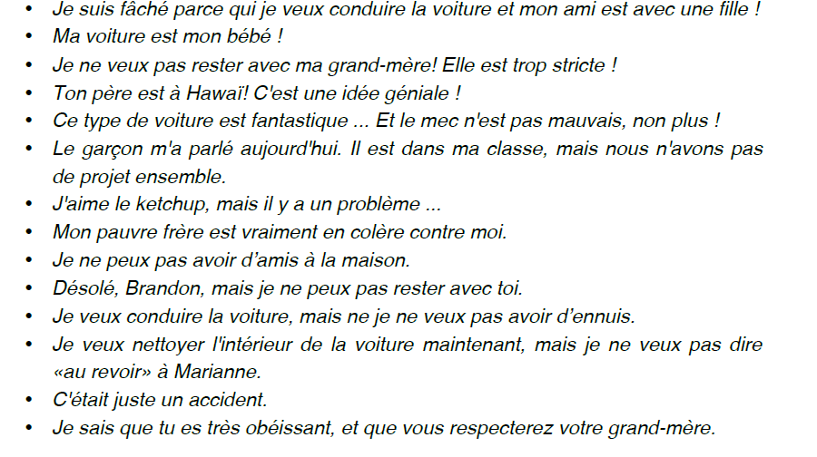

Translate these into English here 1-14.

1. I am mad because I want to drive the car and my friend is with a girl.
2. My car is my baby
3. I don’t want to stay with my grandmother. She is too strict.
4. Your dad is in Hawaii! That is an awesome idea.
5. This type of car is fantastique..And the guy is not that bad either.
6. The guy spoke to me today. He is in my class, but we don’t have any projects together.
7. I like ketchup, but there is a problem.
8. My poor brother is really mad at me.
9. Sorry, Brandon, but I can’t stay with you.
10. I want to drive the car, but I don’t want to have any problems.
11. I want to clean the interior of the car now, but I don’t want to say good-bye to Marianne.
12. It was just an accident.
13. I know that you are very obedient and that you respect your grand-mother.